ACCOMPLISHMENTS...RECOGNITION, AFFILIATIONs AND AWARDS
Ideal Development Agency (IDA)

Name of the Award | Award issuing institution/ Organization | Remarks
(Inter National Level Award )
Civil Society Award- 2006 | UNAIDS ,New Delhi  Year: 2006 | For outstanding commitment and contribution and support to the national towards HIV&AIDS
(National Level Award )
South India Women Achievers Awards (SIWAA)- 2025 | Twell Magazine,Chennai  Year: 2025 | Outstanding accomplishments made by women in South India is strengthened by your ongoing support
Best Citizen Of India Award | International Publishing House  New Delhi  Year: 2002 | For Courageous Contribution in the area of social Welfare and shown a great depth of vision to chalk out the strategies that have been crucial in the setting of a system of assistance for vulnerable women who have nobody to fight for their cause even if they are being exploited or treated cruelly
2019-SAMAJ SAMMAN  ( Life time achievement for Social Service) | The Samaj  Year: 2019-20 | Lifetime Achievement on the eve of The Samaja 100 years’ celebration
Rajib Gandhi Sadbhabana Award-2005 | Rajib Gandhi Foundation ,New Delhi | Best Social Worker(NGO)
State Level Awards
Best Social Work. | KhabarTabar, Award Keonjhar  Year: 1998 | For Best Social Work
Kampal Mohanty Memorial Environmental Award | Nehru Institute of youth Affairs, Bhubaneswar  Year: 1999 | In Creating Environmental Awareness and Environmental Protection
Swarnalata Smurti Puraskar | Swarnalata Smruti Committee, Odisha  Year: 2002 | For decade long contribution towards Social Development in Odisha
Kainchamali Samardhana | Kainchamali Prakashani,Odisha  Year: 2014 | For Contribution Towards Social Work.
Mana Manini Samman-2014 | Mana Manini, NiladreeVihar  Bhubaneswar.  Year: 2014 | Samaj Seba
Biraja Samman-2014 | Ghungur,Natya Anustana,Jajpur  Year: 2014 | Helping the Helpless
Sidheswory Seba Samman-2015 | Punya Utkal Foundation  Year: 2015 | For Spreading the Education for the Vulnerable Children
2ND Odisha State Excellence Awards | Council For Media, Satellite And Broadcasting,New delhi  Year: 2018 | Best Social Worker of the year-2018 Award
Citizens Award-2018 | Keonjhar Development Council(KDC)  Year: 2018 | Best Social service on Promoting innovative agriculture and strengthening livelihood in tribal belt of Odisha.
Krushi Prativa Samman-2018 | ICAR &Odisha KrushakSamaj, and IFFCO,Bhubaneswar  Year: 2018 | On World Food Day for contribution towards a Zero Hunger Generation by 2030
BE THE INSPIRATION for 2018-19 | Rotary International-3262 | Contribution in the field of women empowerment in the District
Nomination for Odisha Citizens Award-2017-18 | OTV | For social Service
Corporate Professional Award-2018 | Konark Entertainment,BBSR | SAMAJA SEBA
Nillimarani Seva Sanman 2021 | Nilimarani Seva Trust,Kalarabank | SAMAJA SEBA
District Level Awards
Mahila Samman | District Administration  Year: 2016 | On the eve of international Women’s Day as Women Achiever for women Empowerment.
Raja Mohastava Award | Raja Mohastava Committee, Keonjhar  Year: 2018 | (District Level Awards)  Service for Ageing
Gopabandhujyoti-2015 | The Samaja | For outstanding Social Work
Mahila Samman | Gandhamardan Iron Ore Mines Suakati  8th March 2023 | On the eve of international Women’s Day as Women Achiever for women Empowerment in Innovation and Technology for Gender equality
Mahila Samman | Barbil Mahila Mahasangha  8th March 2023 | On the eve of international Women’s Day as Women Achiever for women Empowerment

AWARDS
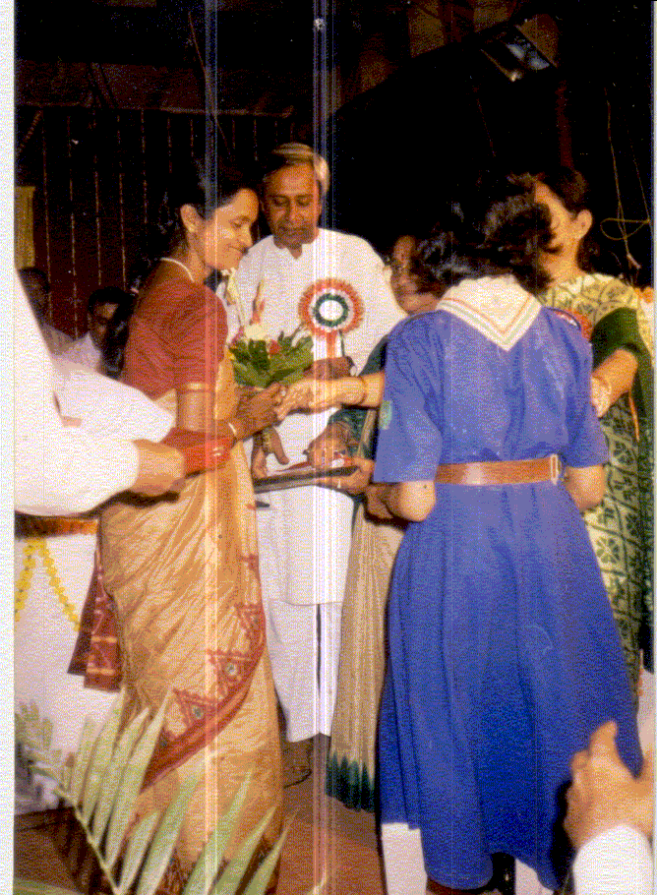 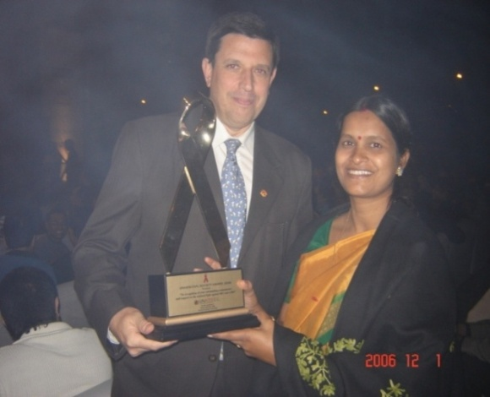 KAMPAL MAHANTY MEMORIAL STATE AWARD UNAIDS CIVIL AWARD -2006
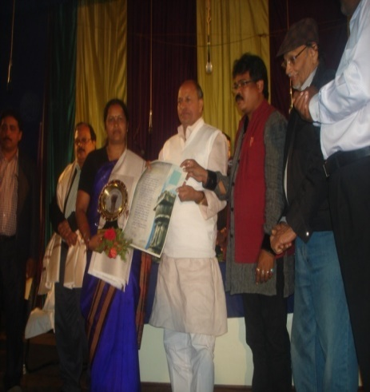
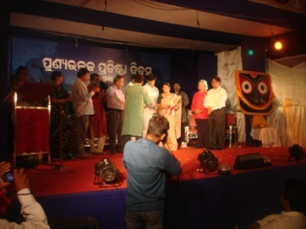

BIRAJASAMMANA-2014 SIDHESWORY SEBA BIRAJA SAMMANA-2015 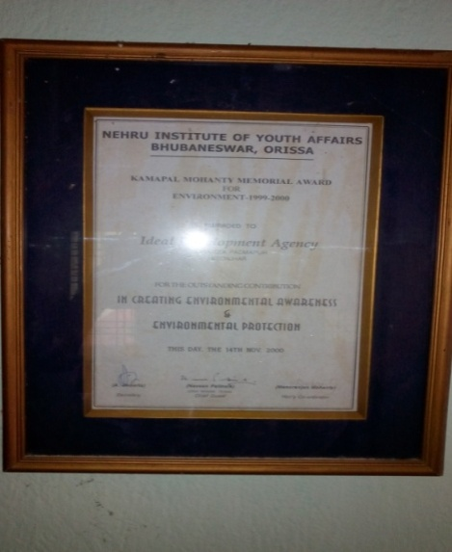 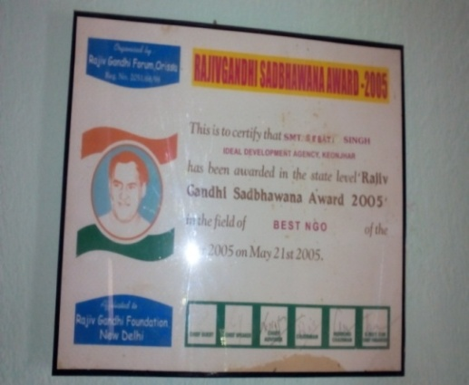
NEHRU INSTRUCTION OF YOUTH AFFAIRS RAJIB GANDHI SADBHABANA AWARD
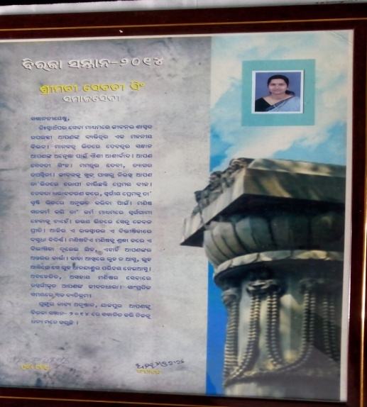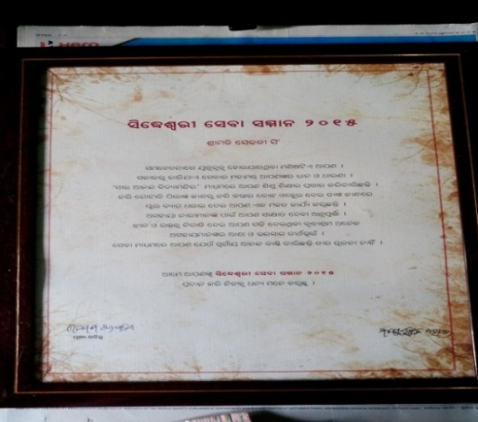

BIRAJA SAMMAN-2014 SIDHESWARY SEBA SAMMANA-2015
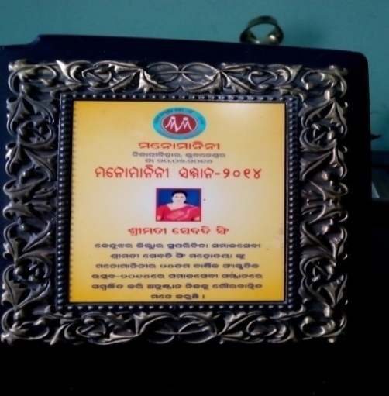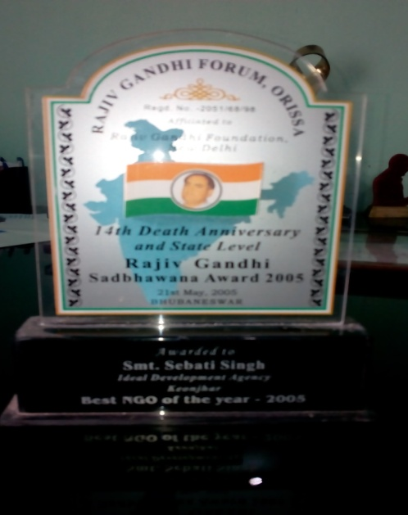
MANAMALINI SAMMANA-2014 RAJIB GANDHI SADBHABANA AWARD
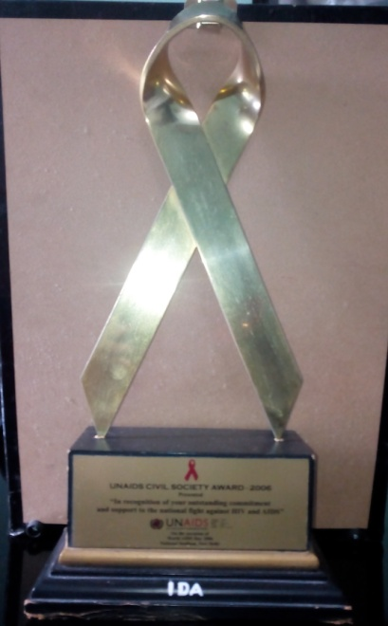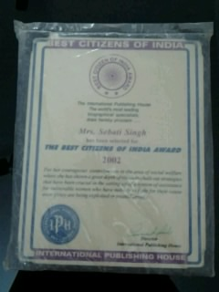
CIVIL SOCIETY AWARD BEST CITIZEN OF INDIA AWARD
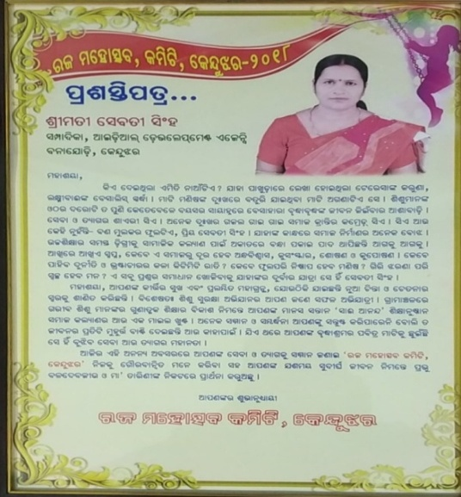
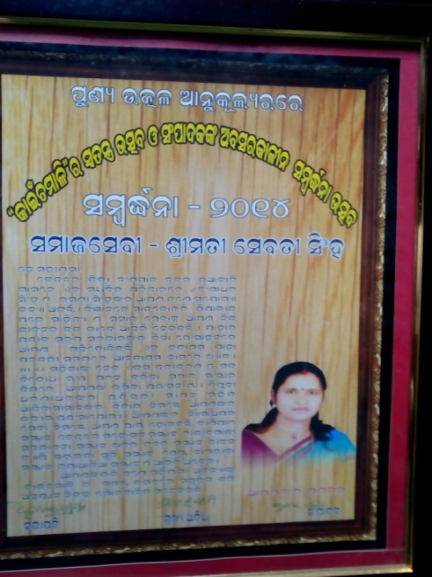
KAINCHAMALISAMARDHANA BEST SOCIAL ACTIVIST AWARD
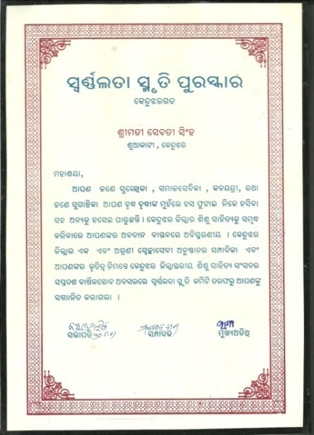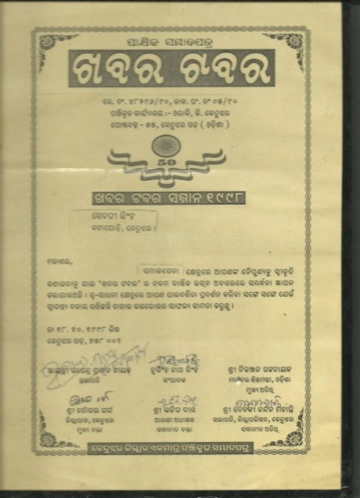
SWARNALATA AWARD KHABAR TABAR AWARD

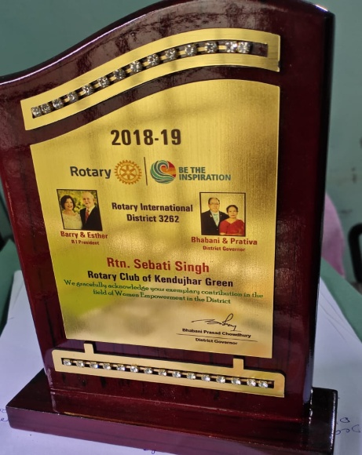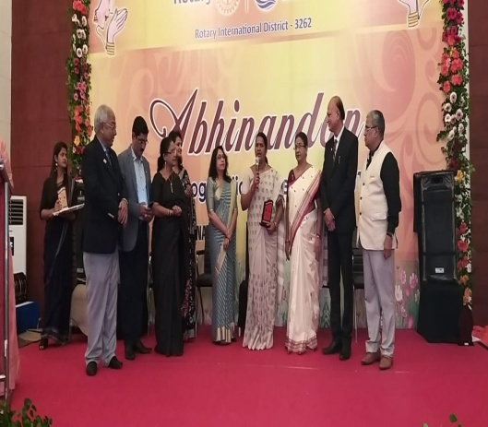
ROTARY INTERNATION AWARDS
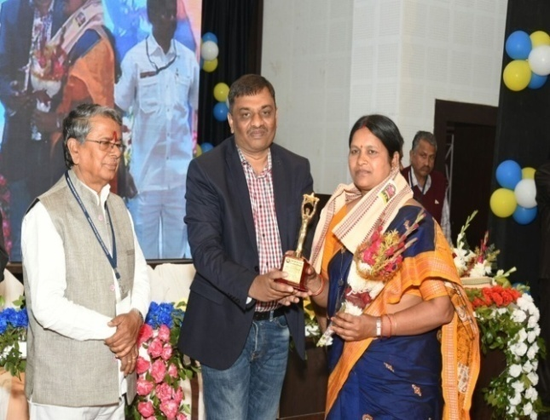
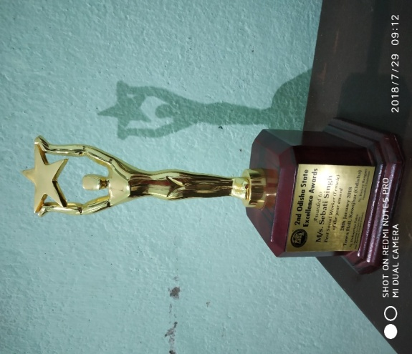

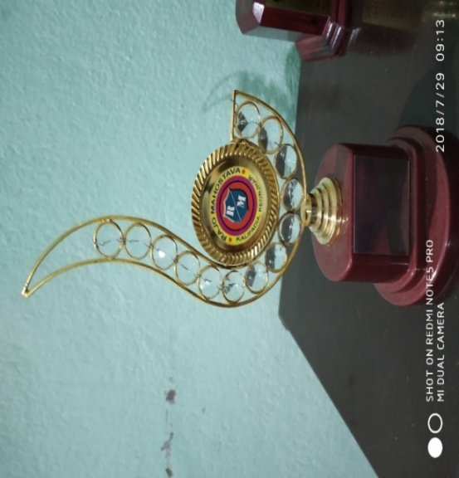
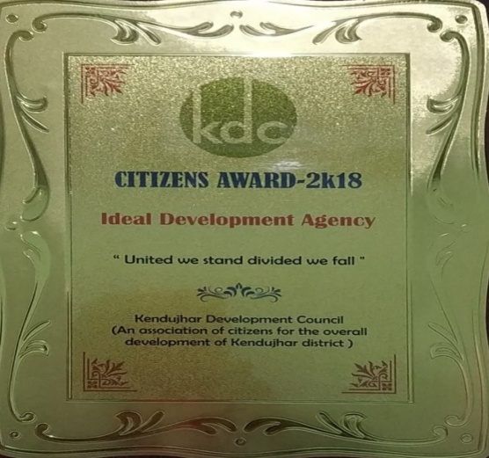
2ND ODISHA STATE EXCELLECE AWARDS

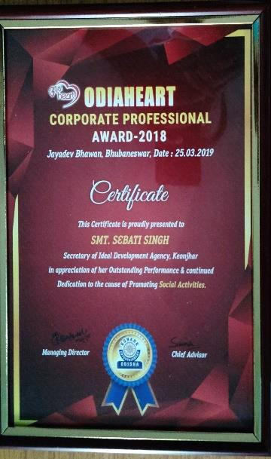
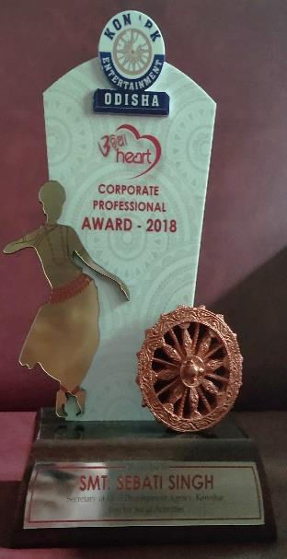
CITIZEN AWARD 2018

CORPORORATE PROFESSIONAL AWARD - 2018
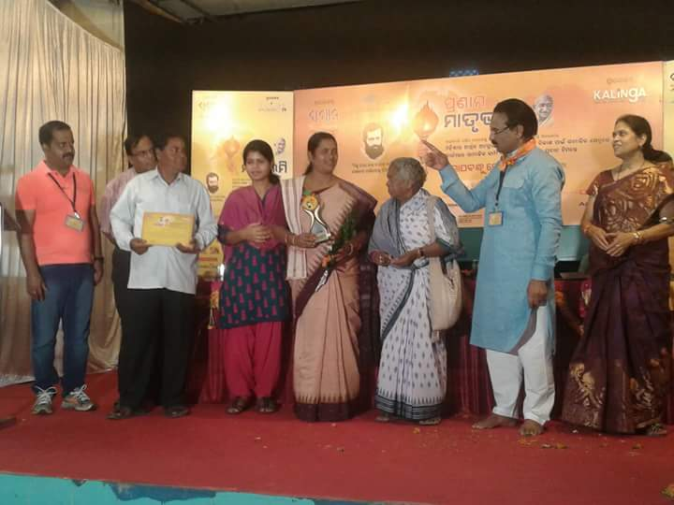
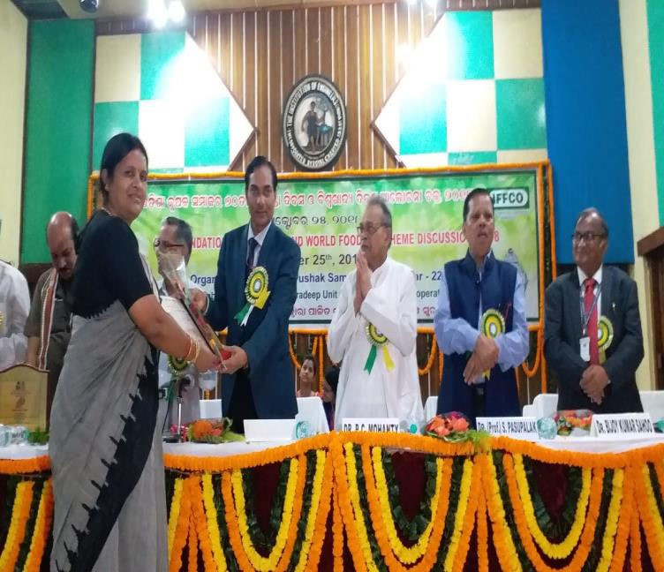

Krushi Prava Samman-2018 FELICIATED IN PRANAM MATRUBHUMI, KEONJHAR

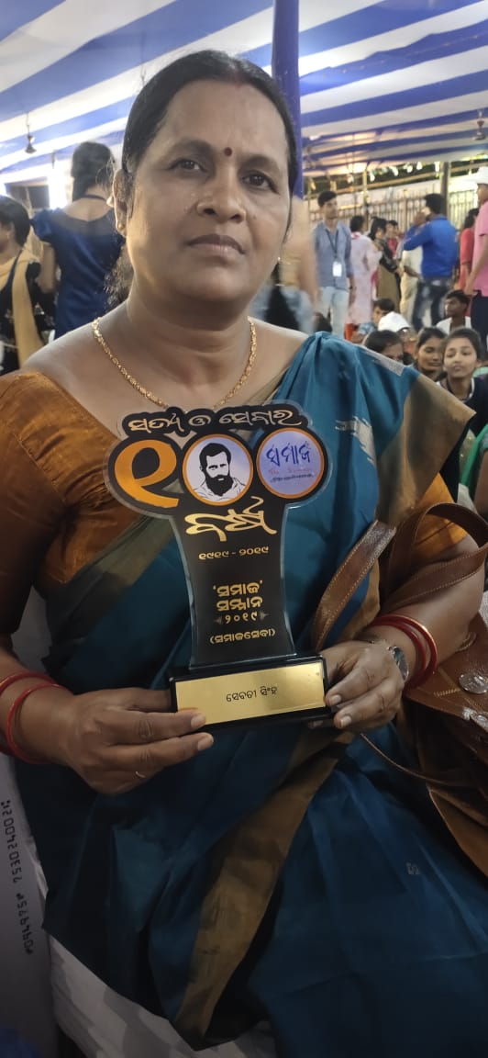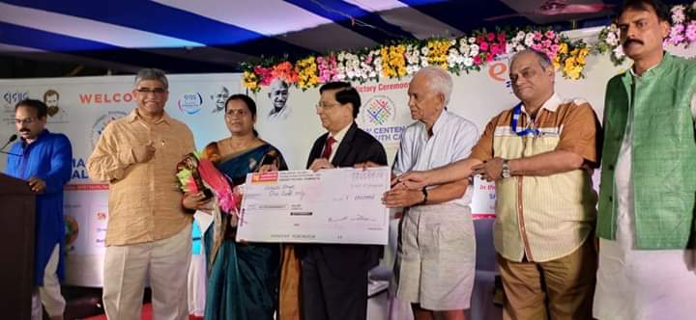

Life time achievement for Social Service by The Samaja

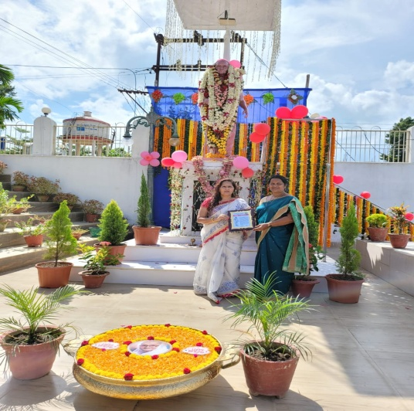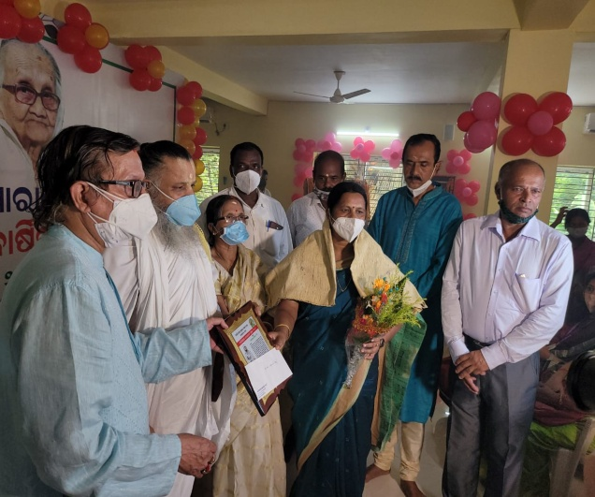
Nillimarani Seva Sanman 2021

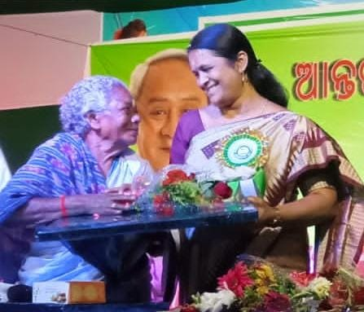
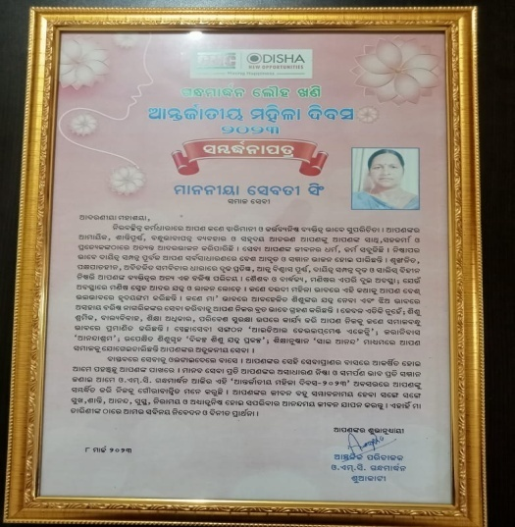
Awarded in International Women’s Day
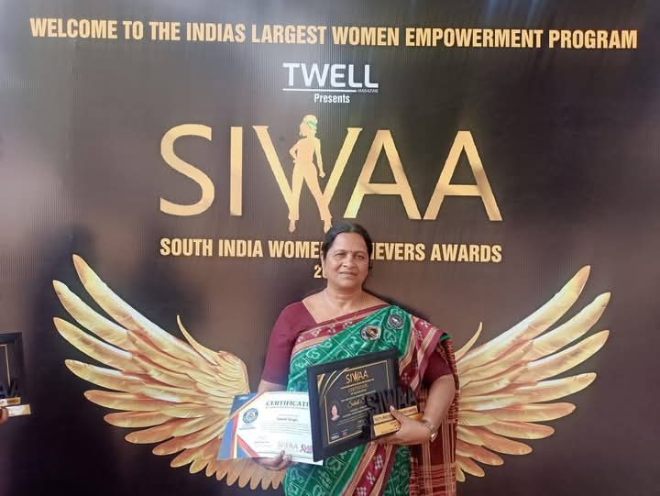
South India Women Achievers Awards (SIWAA)- 2025

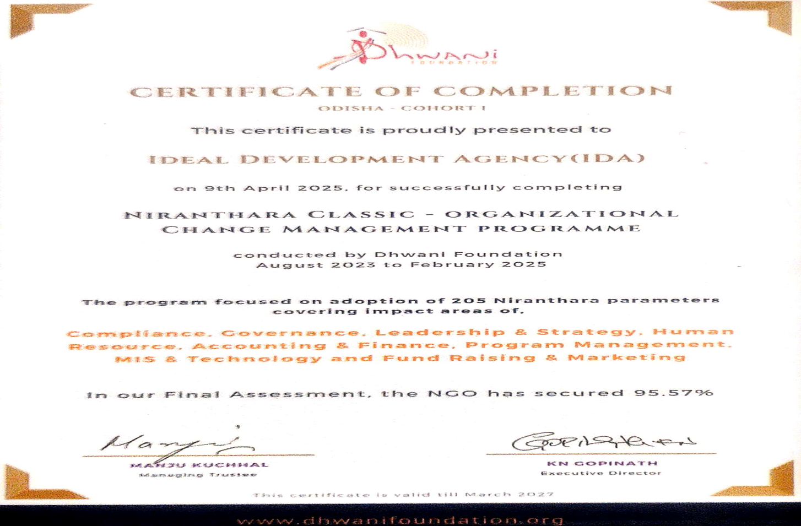
Certificate from Dhwani Foundation for successfully completion of NIRANTHARA CLASSIC Training Programme on Organizational Management- 2025

PUBLICATION IN SOCIAL MEDIA
Publications in YouTube
- https://Youtu.be/-sSETaJvFR4:- Introducing “Your Confident”- #talkto yourconfident, #counsellinginodisha on Mental Health Awareness
- https://Youtu.be/WLkvfN4Bull:- Sebati Singh Success Story- IDA-HD- 2020 on you educate a man ; you educate…
- https://Youtu.be/playlist?list=PL1YdjotfzGo8Bqr2mLsrqONCpL4mFANcm:-Struggling life of Sebati Singh for dream project of Ananda Ashram
- https://Youtu.be/957OJzJ35pE:- AnandaaAsahram. HD Sebati Singh IDA Short Film
- https://Youtu.be/kZSg0O0F9Vc:- Sadara Block Savagruha Swacheyasebi Anustana news10 Odia
- https://Youtu.be/vGobP_MbBps:- Child care HD Sebati Singh IDA Short Film – Analternative Child care concepts
- https://Youtu.be/R9qVu1nrWic :- Sebati Shingh Anandashram a TV Coverage on Mother’s day
- https://Youtu.be/oXMmqku9Lml :- Bitter gourd Cultivation at Satyanarayana Producers Group Sadar block by IDA APC.
- https://Youtu.be/knHyj8n14fs :- Millet Cultivation in tribal area Keonjhar.
- https://Youtu.be/wpRCIM7NFn4:- Sebati Singh Anandaasharam a TV coverage on Mother’s day.
- https://Youtu.be/JRQr-sP6eiQ :- Success story of Sulochana Behera a Beneficiary supported by IDA Bananjodi Keonjhar.
- https://Youtube.com/playlist?list=PLt7qnSaZQKoJy_1KjdheNEQ-8r&IBnPI : Success story of Sulochana Behera a Beneficiary supported by IDA Bananjodi Keonjhar.
- https://Youtu.be/fZIHAYSVH-0:- Holy Observation at Old age Home
- https://Youtu.be/xTrJNKpLjns : Women farmers success during COVID 19
- https://Youtu.be/L04j-XPs1PY: HIV awareness at Keonjhar District by IDA
- https://Youtu.be/SZqZnWN91No : Award 2018 for social work.
- https://Youtu.be/WLkvfN4Bull : Sebati Singh Success Story
- https://Youtu.be/M_h53x-D7BI : Sebati Singh Nkara Sangharsha Kahani # Liveodishanews.
- https://fb.me/1W1PF3Lb5: Maa Pari Kia Heba

